Earthcache
Jill and I worked together this morning to complete this assignment. The nearest Earthcache was about 30 miles from our hometown, so we took a little road trip to Iowa. We actually found 2 geocaches at the same location. One was an Earthcache, and the other a traditional geocache. They were both located outside the North Iowa Welcome Center near Northwood, Iowa. One had a QR code hidden under a picnic table and the other was in an ammo box hanging from a pine tree.
10 Things I learned:
- 3 separate glacial ice sheets once covered northern Iowa
- Clear Lake (just south of the Welcome Center) was formed by glacial action
- An Iowa state park known as Pilot Knob park is one of the highest points in Iowa. This point was formed by glacial activity
- Prairies and great plains were formed as glaciers passed through the areas. Large expanses of flat lands with glacial rock deposits are found near the area that we visited.
- Very little prairie remains in the northern Iowa area. Early settlers once described the area as an ocean of grass which reached 5 feet tall. The area we visited was very urbanized- right next to interstate 35, a McDonald's and a casino. It's incredible to think of the changes this place has seen in just a few hundred years.
- Standing at the Earthcache, the Southwest landscape was the most striking. Although much of it was covered in snow, it was apparent that a flat grassy field was present.
- Surrounding this landscape was lots of farmland. The prairies that once inhabited the area provides nutrient rich soil for agriculture.
- Prairies consist of more than meets the eye. Two thirds of the prairie plants are alive and hidden under the soil
- Fires were an essential component to prairie life. Fires burned prairies and eliminated shallow rooted plants. Deep rooted grasses and plants were able to survive this. This cycle helped to form the soil.
- Earthcaching can lead to other information and resources. Embedded in the Earthcache information was a link to Iowa Prairie Network, which has lots of information and activities surrounding the prairies of Iowa.
Latitude and longitude of traditional geocache: N 43° 26.700' W 093° 21.297'
Latitude and longitude of Earthcache: N 43° 26.724' W 093° 21.263'

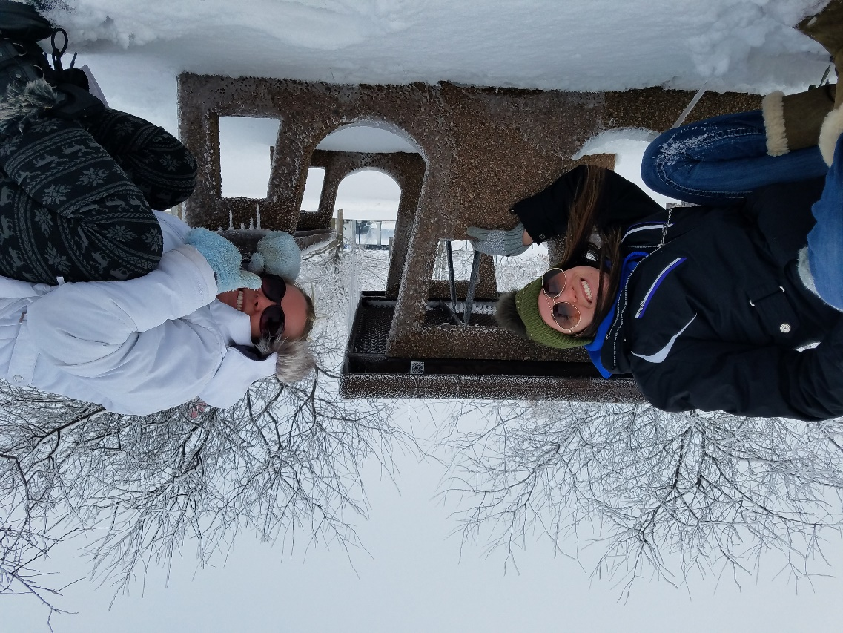
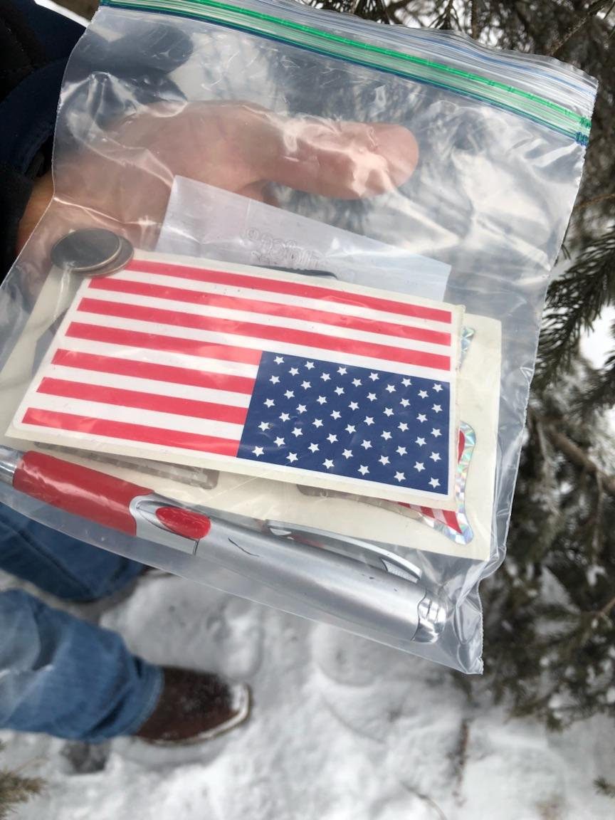
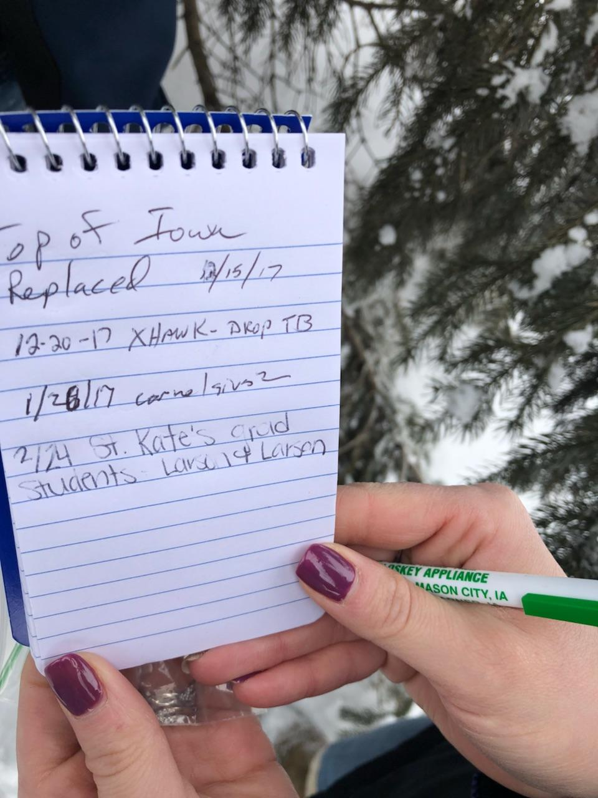
Photos:

